**//31139- Durvesh- CNLA7 (packetanalyzer)**

**Write-up**

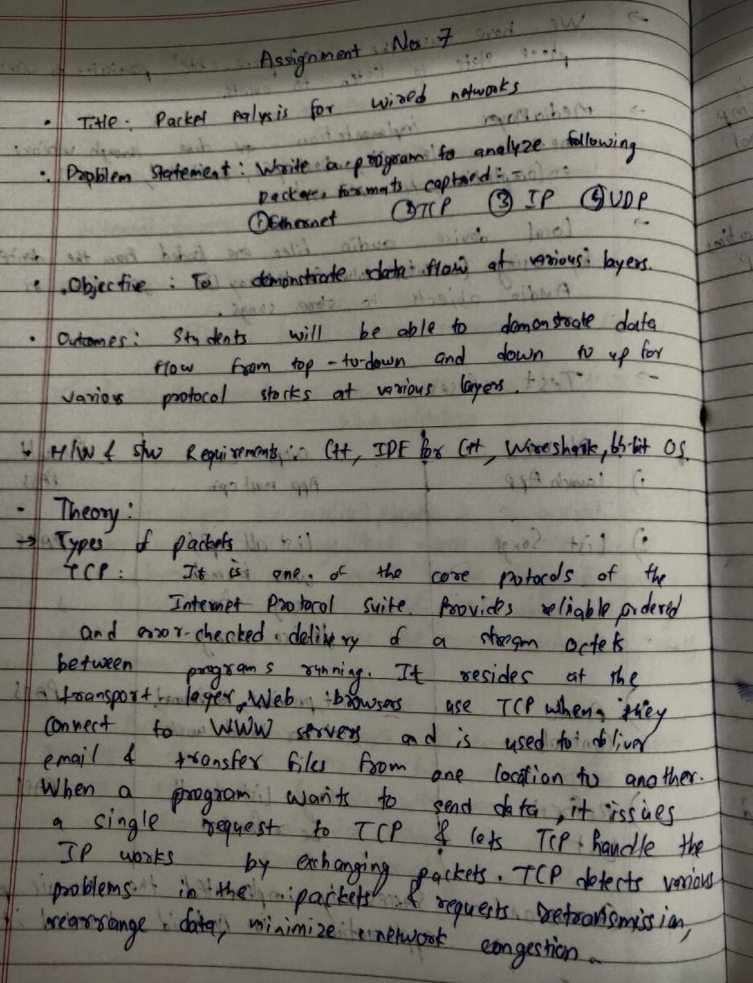

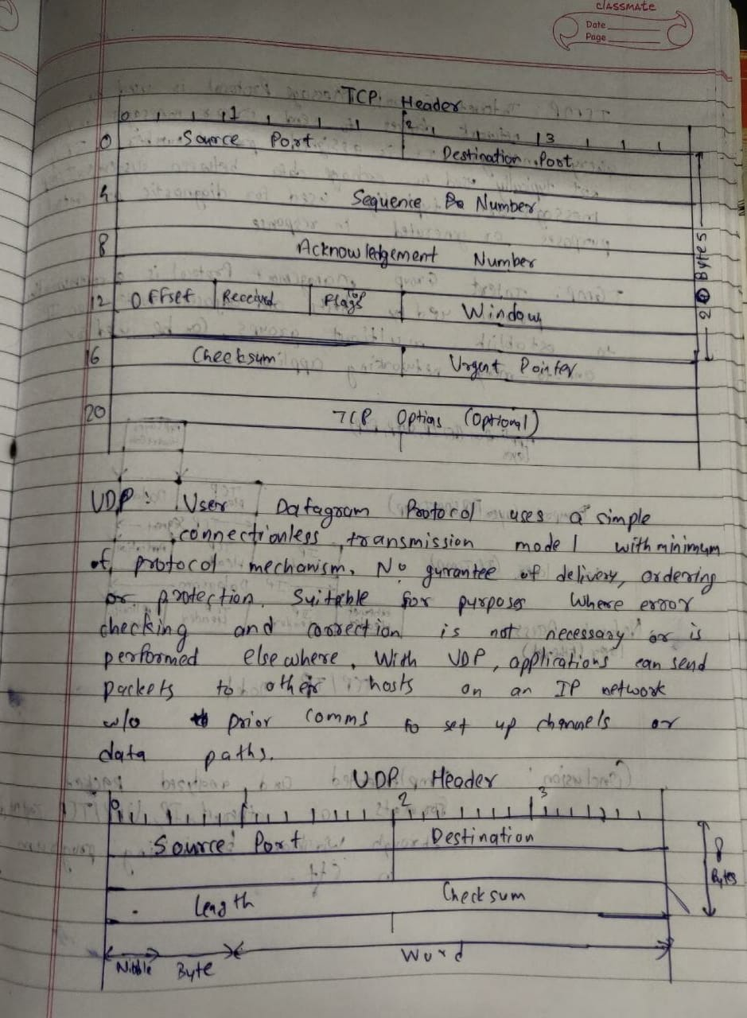

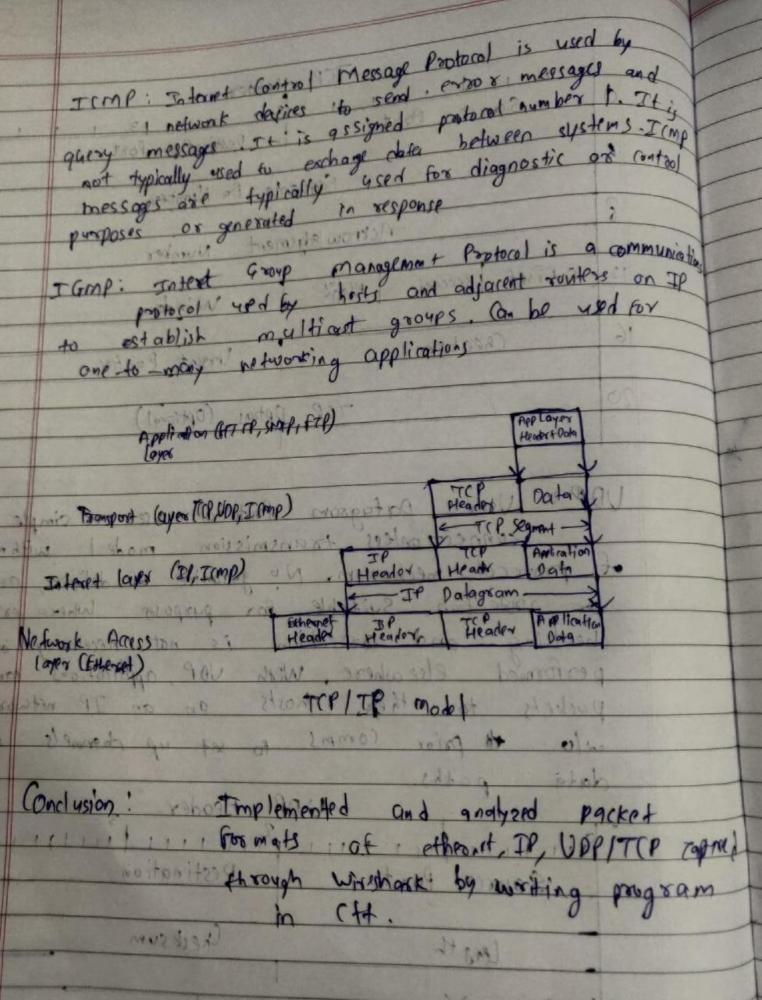

**Code**

-----packetanalyzer.cpp

#include <iostream>

#include<fstream>

#include <iomanip>

#include<string>

using namespace std;

int main() {

cout << "-------------PACKET ANALYZER----------" << endl;

string value, sr_no,time,source,destination,info,protocol,len;

int count=-1,i=0;

int choice=0;

while(choice!=5)

{

ifstream file("data.csv");

count=-1;

i=0;

cout<<"\nEnter which protocol packets you want to see"<<endl;

cout<<"1.IP\n2.UDP\n3.TCP\n4.Ethernet\n5.Exit!!!\nChoice:";

cin>>choice;

string protocolChoice;

string[] protocolChoices=["ICMPv6","UDP","TCP","ARP"];

if (choice>5 || choice<1){

protocolChoice = "ARP";

}

else if(choice==5){

break;

}

else{

protocolChoice = protocolChoices[choice-1];

}

if(choice==5){

break;

}

while(file.good())

{

getline(file,sr_no,',');

getline(file,time,',');

getline(file,source,',');

getline(file,destination,',');

getline(file,protocol,',');

getline(file,len,',');

getline(file,info,'\n');

protocol=string(protocol,1,protocol.length()-2);

if(protocol=="Protocol"||protocol==protocolChoice)

{

cout <<setw(4)<<left<<i++;

cout <<setw(12)<<left<< string( time, 1, time.length()-2 );

cout << setw(30)<<left<<string( source, 1, source.length()-2 );

cout << setw(30)<<left<<string( destination, 1, destination.length()-2 );

cout <<setw(8)<<left<<protocol<<" ";

cout <<setw(8)<<left<< string( len, 1, len.length()-2 );

cout << string( info, 1, info.length()-2 )<<"\n";

count++;

}

}

file.close();

cout<<"\nTotal Packet Count: "<<count<<endl;

}while(choice!=5);

return 0;

}

**Outputs:**

